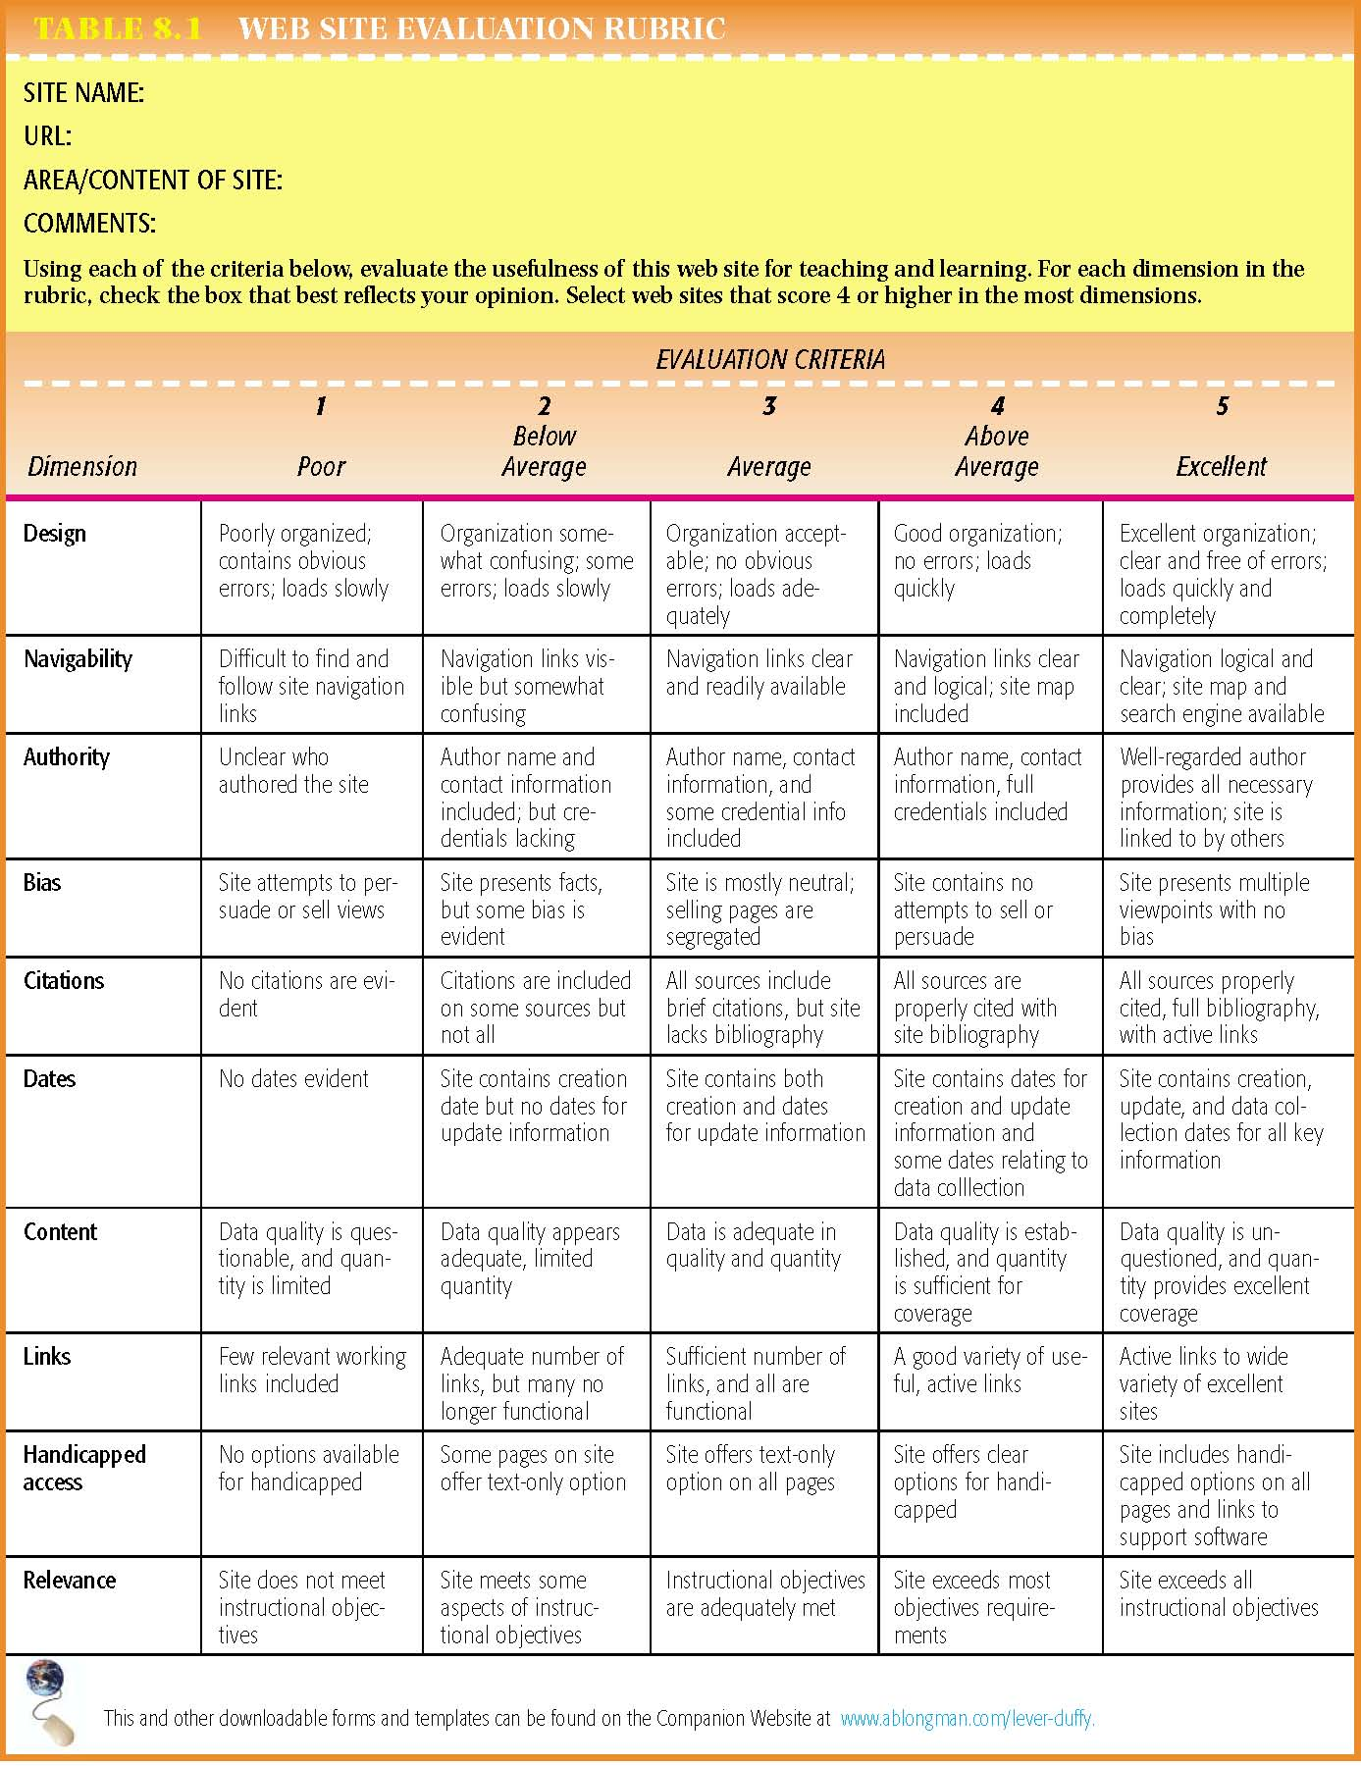
Website Evaluation Tool
Evaluating websites
Use the rubric above to evaluate two of your websites. Place a numeric value for each of the criteria (except column one where you are to record the URL of the website).
 | Website 1 | Website 2
URL
(web address)
Authority
Bias
Citations
Last updated
Content
Links
Relevance

