Using Audacity to make a podcast

Audacity is a free software package that can record and edit your podcasts for uploading. Setting up is a bit of a process, but you only need to do it once

Installing Audacity
- Go to http://audacity.sourceforge.net/download/
- Choose the download link for your operating system
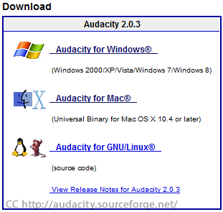
and select the installer
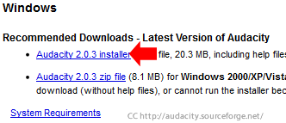 | 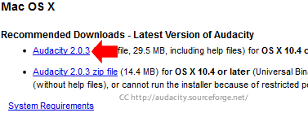

- Save the installer file to your computer, and then install the program from your download folder
If you are using a Curtin University computer, you may need to give yourself Administrator rights to install the program. Curtin IT services (x9000) can assist you with this.

Installing the LAME MP3 Encoder
MP3’s are a common format for sound files that students will be able to play on almost any device (IPod, smartphone etc). To encode as an mp3 you will need to install the LAME encoder.
- Go to http://lame1.buanzo.com.ar/
- Click on the appropriate download link for your operating system. The most common download links are highlighted, but it may not always be right for your system
  - Windows XP, 7 and 8
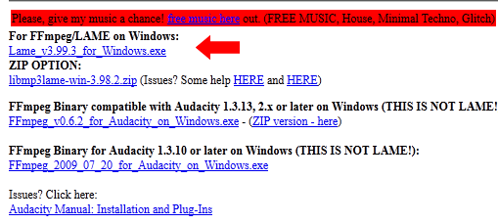
  - Mac
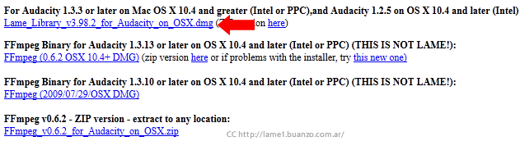
- Download and install the LAME package by opening the file in your download folder

Using Audacity
Using Audacity to record audio is actually very easy. The Audacity interface looks very complicated, but you only need to use a few buttons to record your feedback.
Start/Continue Recording
Stop Recording (Only use this when you are finished recording)
Pause recording (handy if you want to take a break in the middle of a recording)
Play recording (useful for reviewing your feedback before you finish)
Skip to the start/end of the recording

Beyond the simple instructions here, refer to the Audacity Wiki (http://wiki.audacityteam.org/). These instructions will show how to record
It is important that you have your microphone set up before you begin recording. If you have your microphone set up for using Blackboard Collaborate, you should be ready to go.
An ordinary podcast recording might look like this
- Write your script, do any preparation work required
- Get your headset/microphone set up
- Open Audacity
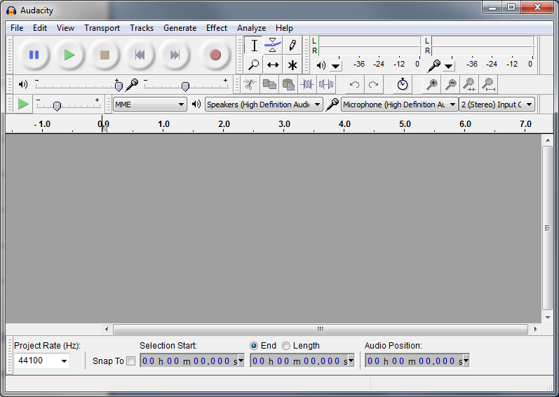
- Click the ‘Start Recording’ button
- Audacity will start to record your voice as you speak, and the red line will travel right as time passes.
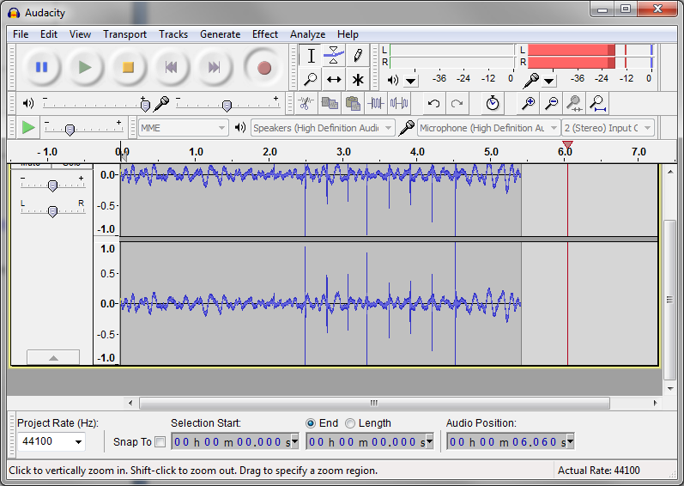
You can check that your voice is being recorded as when you speak there will be spikes in the blue lines.
- You can pause the recording (if you need to take a break, or the cat jumps on the keyboard) by clicking on the pause button
Clicking on the button again will continue the recording
- When you are finished recording, press the stop button
if you discover you need to keep recording after hitting stop, you can Shift+click on the record button to append the new recording to the end of the last one
- To listen to the recording, press the play button
Audacity can allow you to edit recordings before you export them to Mp3. You can find information on editing recordings on http://wiki.audacityteam.org .
To start a new recording, choose File> New recording.

Extracting the Mp3 for Upload
If you are happy with the recording, and want to extract the recording for uploading , follow these steps
- In the File menu, select Export
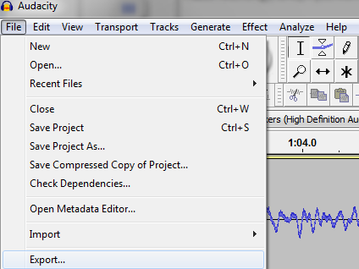
- Select where you would like the .mp3 file to be created and enter the file name
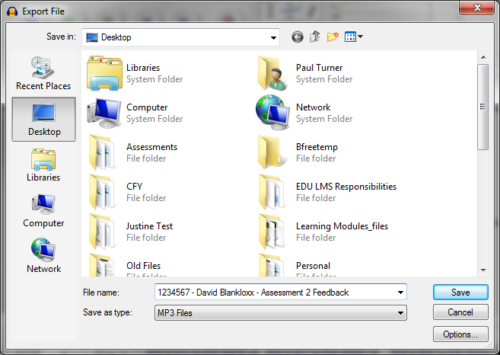
- Select OK
- The file will appear in the location you selected.

To upload files to your Weekly Tasks Journal
- Click on ‘Create Journal Entry’
- Enter a title for the entry
- Enter some information about your Portfolio 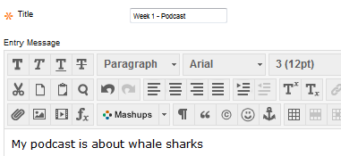
- To attach your portfolio file, select ‘Browse My Computer’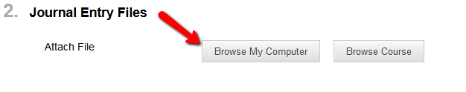
- Locate the file on your computer
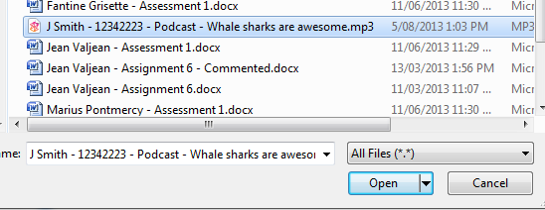
and click ‘Open’
It is best to name your file something recognisable, such as
Your Name – Student number – Assignment name - Title

- The file will appear
- Hit Post Entry

