ACTIVITY 4: CLEANING MUDDY WATER

Students make a simple sand and gravel filter to clean muddy water and make it suitable for washing (not drinking).

Preparation (for each group)
- one cup of muddy water
- flowerpot
- metal stand for flowerpot, to allow drainage
- clean glass jar
- two cups of sand
- two cups of gravel
- absorbent paper (such as paper towel or blotting paper).

Read the case study below before you start

Use information from the case study, and any other examples you may know about, to discuss water sources that people might depend on if there is no convenient access to water where they live.

- Would the water always be clean enough to use (eg to drink, to cook with, to wash with, to water plants, to give to animals)?
- Why or why not? What could happen if water was used for a purpose for which it was not clean enough?
- Why might it be helpful to have methods of making water cleaner?

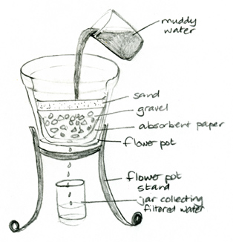

Follow the steps below to construct a water filter for cleaning muddy water to make it suitable for washing.

Method
- Line the flowerpot with absorbent paper so that it comes up the sides of the pot.
- Pour in the gravel.
- Pour in the sand.
- Place the flowerpot in the metal stand.
- Place the jar under the drainage hole of the flowerpot.
- Stir your cup of muddy water and slowly pour this into the middle of the flowerpot.
- Observe the water that drains from the flowerpot into the jar.

Questions to answer
- What colour was the muddy water?
- What colour was the filtered water?
- How well did your filter work? What did it remove from the muddy water?
- Were other students’ filters as good as yours? Why or why not?
- How could you use this filtered water?
- What could you do to make it suitable to drink
- Draw your water filter and explain how it works. Describe how it could assist people who do not have access to clean water.

Mekong Delta water and sanitation
Developing water and sanitation systems has improved the health of people living along the Mekong River, and the local economy.

Cuu Long Delta water and sanitation
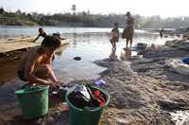
Poor water, inadequate sanitation and a lack of safe drinking water cause diarrhoea, dengue fever, malaria, and eye and skin diseases. The Mekong or Cuu Long Delta Rural Water Supply and Sanitation Project engaged the people and governments of Vietnam and Australia in working together to improve water and sanitation. It improved the overall living standards and health of 500,000 poor people. The project had a major emphasis on achieving the participation of women in all aspects of the project.
People bathe and do their laundry on the banks of the Sekong River in southern Laos before it joins the Mekong River.
Photo by Jim Holmes for AusAID

Water supply
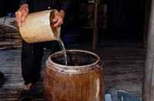
Water access for many poor people in the region was through unsafe sources, such as stagnant ponds, open wells and polluted rivers. Families, particularly women, spent large amounts of time and energy collecting water for basic household needs; often paying 3–10 times the local price for small quantities of potable water. Piped water was available only a few hours each day.
The project expanded the water supply systems, increasing access to potable, reliable piped water. It supplied safe drinking water to 70–80% of the population, 24 hours a day. Safe drinking water became available to poorer households, close to their homes and at an affordable cost. This meant water-related diseases declined and poverty decreased.

Sanitation
Flooding, polluted canals, lack of drainage, untreated industrial waste water, lack of toilets in homes and schools, lack of solid waste collection services, and inadequate waste disposal sites made illness common, particularly among the poor. Waste water flowed directly into open drains or the river.

The project involved local communities in the design and construction of improved drainage and sanitation services (toilets, drainage and collection of solid waste). The project built 120 blocks of toilets in schools and ran programs to promote personal hygiene. Students’ hand cleanliness improved and good toilet maintenance was observed.

Ongoing maintenance
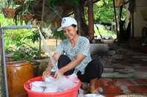
Staff training, purchasing of new tools and equipment, and long-term planning are often limited by lack of money. The project supplied equipment and trained local people in water and sanitation technology to ensure that the systems could be well maintained beyond the completion of the project.
Improved water and sanitation systems are not only improving the health of people in the Cuu Long Delta, but also the economy. Staff, particularly women, have been employed to manage the maintenance and community education programs. With a stable water supply, small-scale industries such as gardening, fish farming and the processing of agricultural products are able to develop.

This activity adapted from
http://www.globaleducation.edu.au/case-studies/mekong-delta-water-and-sanitation.html

