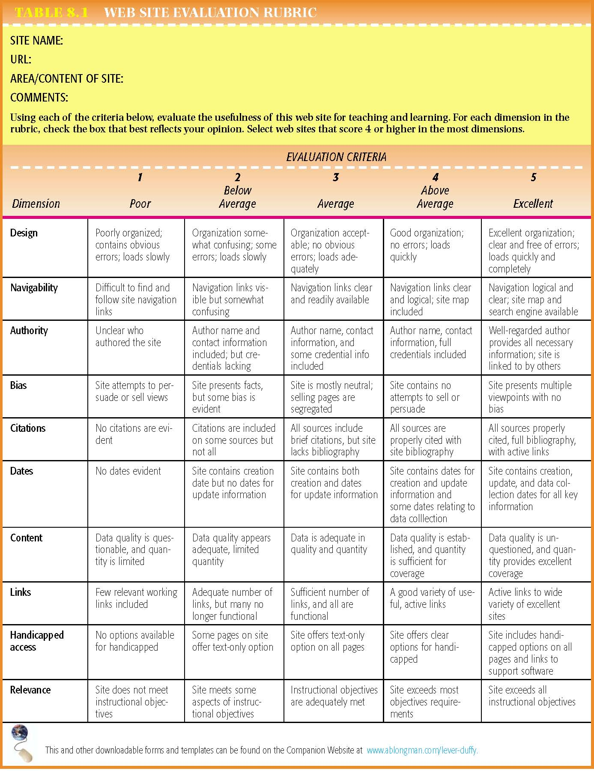
Website Evaluation Tool
Evaluating websites
Use the rubric above to evaluate two of your websites. Place a numeric value for each of the criteria and add a comment (positive or negative) if you can.
 | Website 1  Name:  URL: |  | Website 2  Name:  URL:
 | Score /5 | Comment | Score /5 | Comment
Authority
Bias
Citations
Last updated
Content
Links
Relevance

