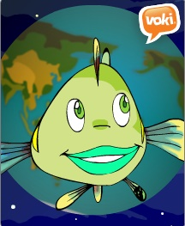
Name_____________________ Class ________
Year 7 Water Checklist 2015
- These are the tasks that you need to complete as you work your way through the inquiry process.
- When you have completed each task, tick the box and then show your teacher so they can sign off that this task is complete.
Task |  |  |  |  | I have completed this task | Teacher signature
- Before You Start
• Review website and be familiar with the navigation• Complete the online survey
- Our Team • Choose your team and list their names here
- Our Topic
• We have created a Voki to explain our project. The URL for the Voki is:
• We have created a concept map/mind map. The tool we used is:
- Our Questions • I have used the information on the website to create my questions
Q1.
Q2.
Q3.
- Our Research  • I have identified the websites that we will use for our inquiry  • I have reviewed two of these websites using the evaluation tool. |  |  |  | Overall rating
Website 1:
Website 2:
- Communicating
• I have read the marking rubrics and used these to plan our Presentation
- Reflection • I have completed the online survey

