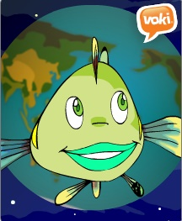
Name_____________________ Class ________
Year 7 Water Checklist
- These are the tasks that you need to complete as you work your way through the inquiry process.
- When you have completed each task, tick the box and then show your teacher your work as evidence so they can sign off that this task is complete.
Task |  |  | I have completed this task  (Sign) | Teacher signature
- Before You Start
• Read and watch the videos • Download the outline • Complete the online survey

- Our Team • List the name of your partner here
- Science Inquiry: List 3 things you have learned from the story of inquiry
- Our Topic
• We have created a Voki to explain our project. The URL for the Voki is:
• We have created a concept map/mind map. The tool we used was:
- Our Questions • I have used the question matrix to create our questions
Q1.
Q2.
Q3.
- Our Research  • I have identified the websites that we will use for our inquiry  • I have reviewed two of these websites using the evaluation tool. |  | Overall rating
Website 1: URL
Website 2: URL
- Communicating I have read the marking rubrics and used these to plan our work
• Our Report
• Our Presentation
- Reflection • I have complete the online survey

